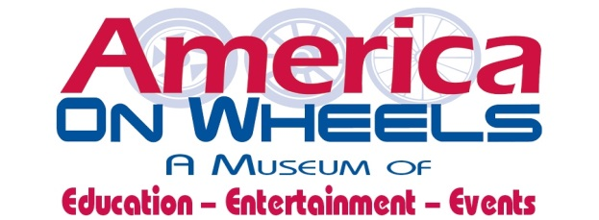

PERMISSIONS & LIABILITY WAIVER
Return this form to: 5 North Front Street, Allentown PA 18102 610.432.4200 OR email to: museumadmin@americaonwheels.org

I ____________________________________________give the America On Wheels Museum located in Allentown, Pennsylvania, permission to provide Basic First Aid treatment as appropriate and in accordance with the ability of the staff. Basic First Aid includes: application of band-aids for minor cuts or scrapes; providing ice packs for minor bumps and bruises. America On Wheels will not provide aspirin, ibuprofen, or other medication to any child without permission from a parent/guardian. I understand that in case of emergency, my child will be taken to a local hospital, and while my child is transported to the hospital, America On Wheels will begin immediate attempts to contact the parents/guardians. I give permission to the physician selected by America On Wheels or by the parent/guardian to begin routine treatment (please circle preference).
I _____________________________________________ give the America On Wheels Museum of Allentown permission to photograph my child during their camp experience. I understand that my child’s name will not be mentioned if photograph is shown on museum website showing camp activities.
This release covers all events and camp activities associated with the program. I understand that if I have any concerns about my child’s health or ability to participate in camp, it is my responsibility (as the parent or guardian) to discuss all concerns with the Museum Administration. All calls can be directed to 610.432.4200 x 11. I have shared the camp’s expectations with my child and feel that he/she understands what is expected during camp. I also understand that should he/she be unwilling or unable to participate or get sick, I will be called immediately. Parents must pick up their child within 1 hour of a phone call unless other arrangements are explained to the Museum Administration.
By signing this Liability Release, you are expressly releasing and waiving any rights against the America On Wheels Museum, its Board of Directors, Staff or Volunteers from any liabilities, claims, injuries or damages of any kind. I understand that the Museum’s goal is to provide a wonderful camp experience filled with laughter, creativity and a memorable time.
Parent/Guardian Name: ________________________________________________________________
Signature:____________________________________________________________________________
Date:________________________________________________________________________________
Any additional comments: ______________________________________________________________
America On Wheels will keep a copy of this Liability Form on File: 2019 Summer Camp

