Tour

A

Schedule

Group

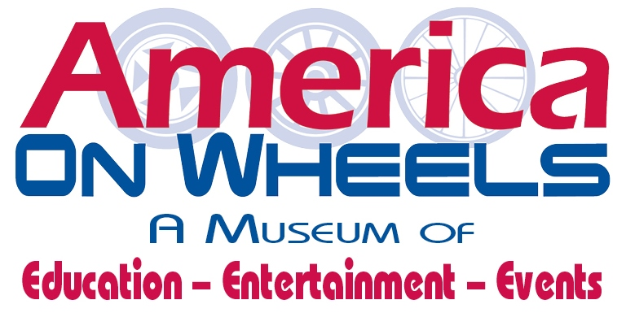

**GROUP TOURS** are available to any group of 10 or more

* Guided Tour

*(Docent for every 10-15 people)*

* Self-Guided Tour

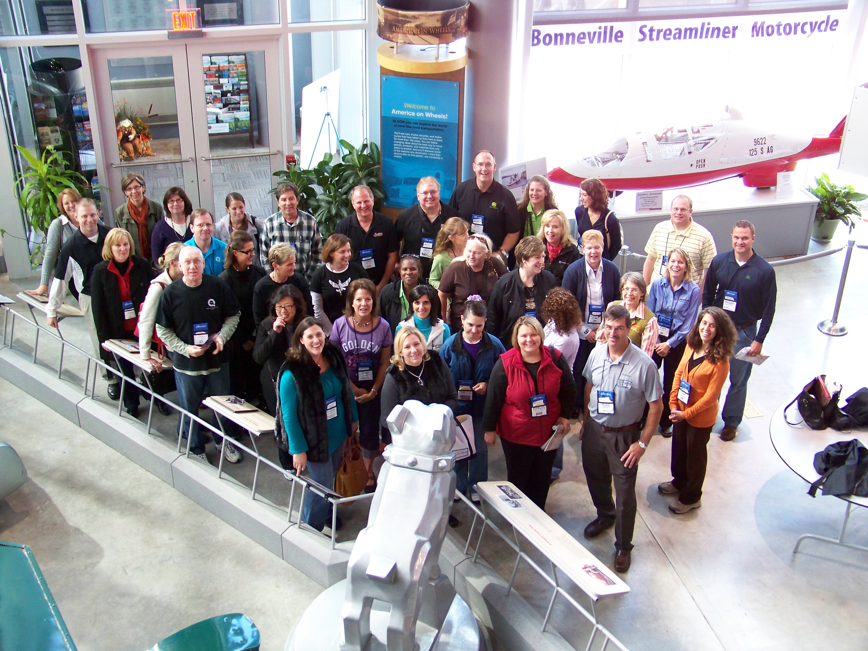

**FREE PARKING**

Bus Parking Available

America On Wheels is Handicap Accessible

**TOUR PACKAGES**

* *Tour Packages consist of groups of 10 or more*

**TOUR ONLY** – Adult/$8 – Child/$6

**TOUR & ICE CREAM** – Adult/$10 – Child/$7

Tour & Double Scoop Ice Cream (Cup/Cone)

**Roadside Treats** – Adult/$18 – Child/$12

**Includes-** Tour,2 Hot Dogs, Chips, Soda/Water

Double Scoop Ice Cream (Cup/Cone)

**THE WHEEL OF TRANSPORTATION** – Adult/$22 – Child$16

Includes: Tour, Sandwich Tray, Pickles, Potato Chips, Soda/Water, Double Scoop Ice Cream (Cup/Cone)

**GROUP RATES**

*(10 or more paying individuals)*

**Adults/Seniors:** $8.00

**Students (6-16):** $6.00

**5 & under:** FREE

*Please pay upon arrival on the day of your tour*

Cash, Check, Visa and MasterCard accepted

**HOURS**

**(January through March)**

Wednesday through Saturday 10am-4pm

Sunday 12pm-4pm

*Last Ticket Sales at 3pm*

**(April through December)**

Tuesday through Saturday 10am-4pm

Sunday 12pm-4pm

*Last ticket sales at 3pm*

Please reserve your tour at least two weeks in advance by calling America On Wheels at 610-432-4200 x 10 or by downloading an on-line reservation form by visiting our website at [www.americaonwheels.org](http://www.americaonwheels.org).

MAIL OR FAX TO:

**America On Wheels,** **5 North Front Street, Allentown, PA 18102 FAX: 610-432-3670**

**HOW TO SCHEDULE A VISIT**

**FOR RESERVATIONS AND/OR FURTHER INFORMATION PLEASE CALL LIZ HAHN AT 610-432-4200 OR EMAIL AT** [**fund_development@americaonwheels.org**](mailto:fund_development@americaonwheels.org)