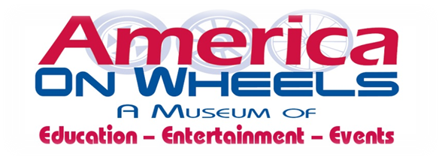

Bulldog Beauty Contest Registration Form
April 28, 2019 1:00PM – 3:00PM
(Registration begins at 12:30pm)

America On Wheels Museum
5 North Front Street
Allentown, PA 18102
610-432-4200 – www.americaonwheels.org

Please include photo of your Bulldog ~ Photos will not be returned ~ Contest judged by local celebrities

Owner information handling Bulldog at America On Wheels Museum:

First Name: _______________________________ Last Name: _________________________________________

Address: ____________________________________________________________________________________

City: ___________ State: ___________ Zip Code: ___________Phone #: ________________________________

E-mail Address: ______________________________________________________________________________

Name of Bulldog: _____________________________________________________________________________

Tell us a little about your bulldog to be shared during contest:

PHOTO RELEASE

I understand that photos may appear in published material(s) and/or on the America On Wheels Museum website.

SIGNATURE: _______________________________________ PRINT NAME: ________________________________

Please mail registration form by April 16, 2019
Accepting the first 30 Bulldogs


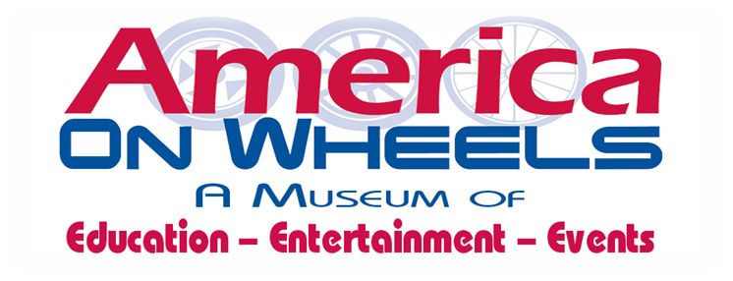











10th Annual
Bulldog Beauty Contest
Sunday, April 28, 2019
1:00pm – 3:00pm



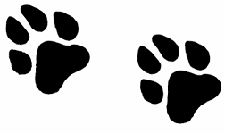



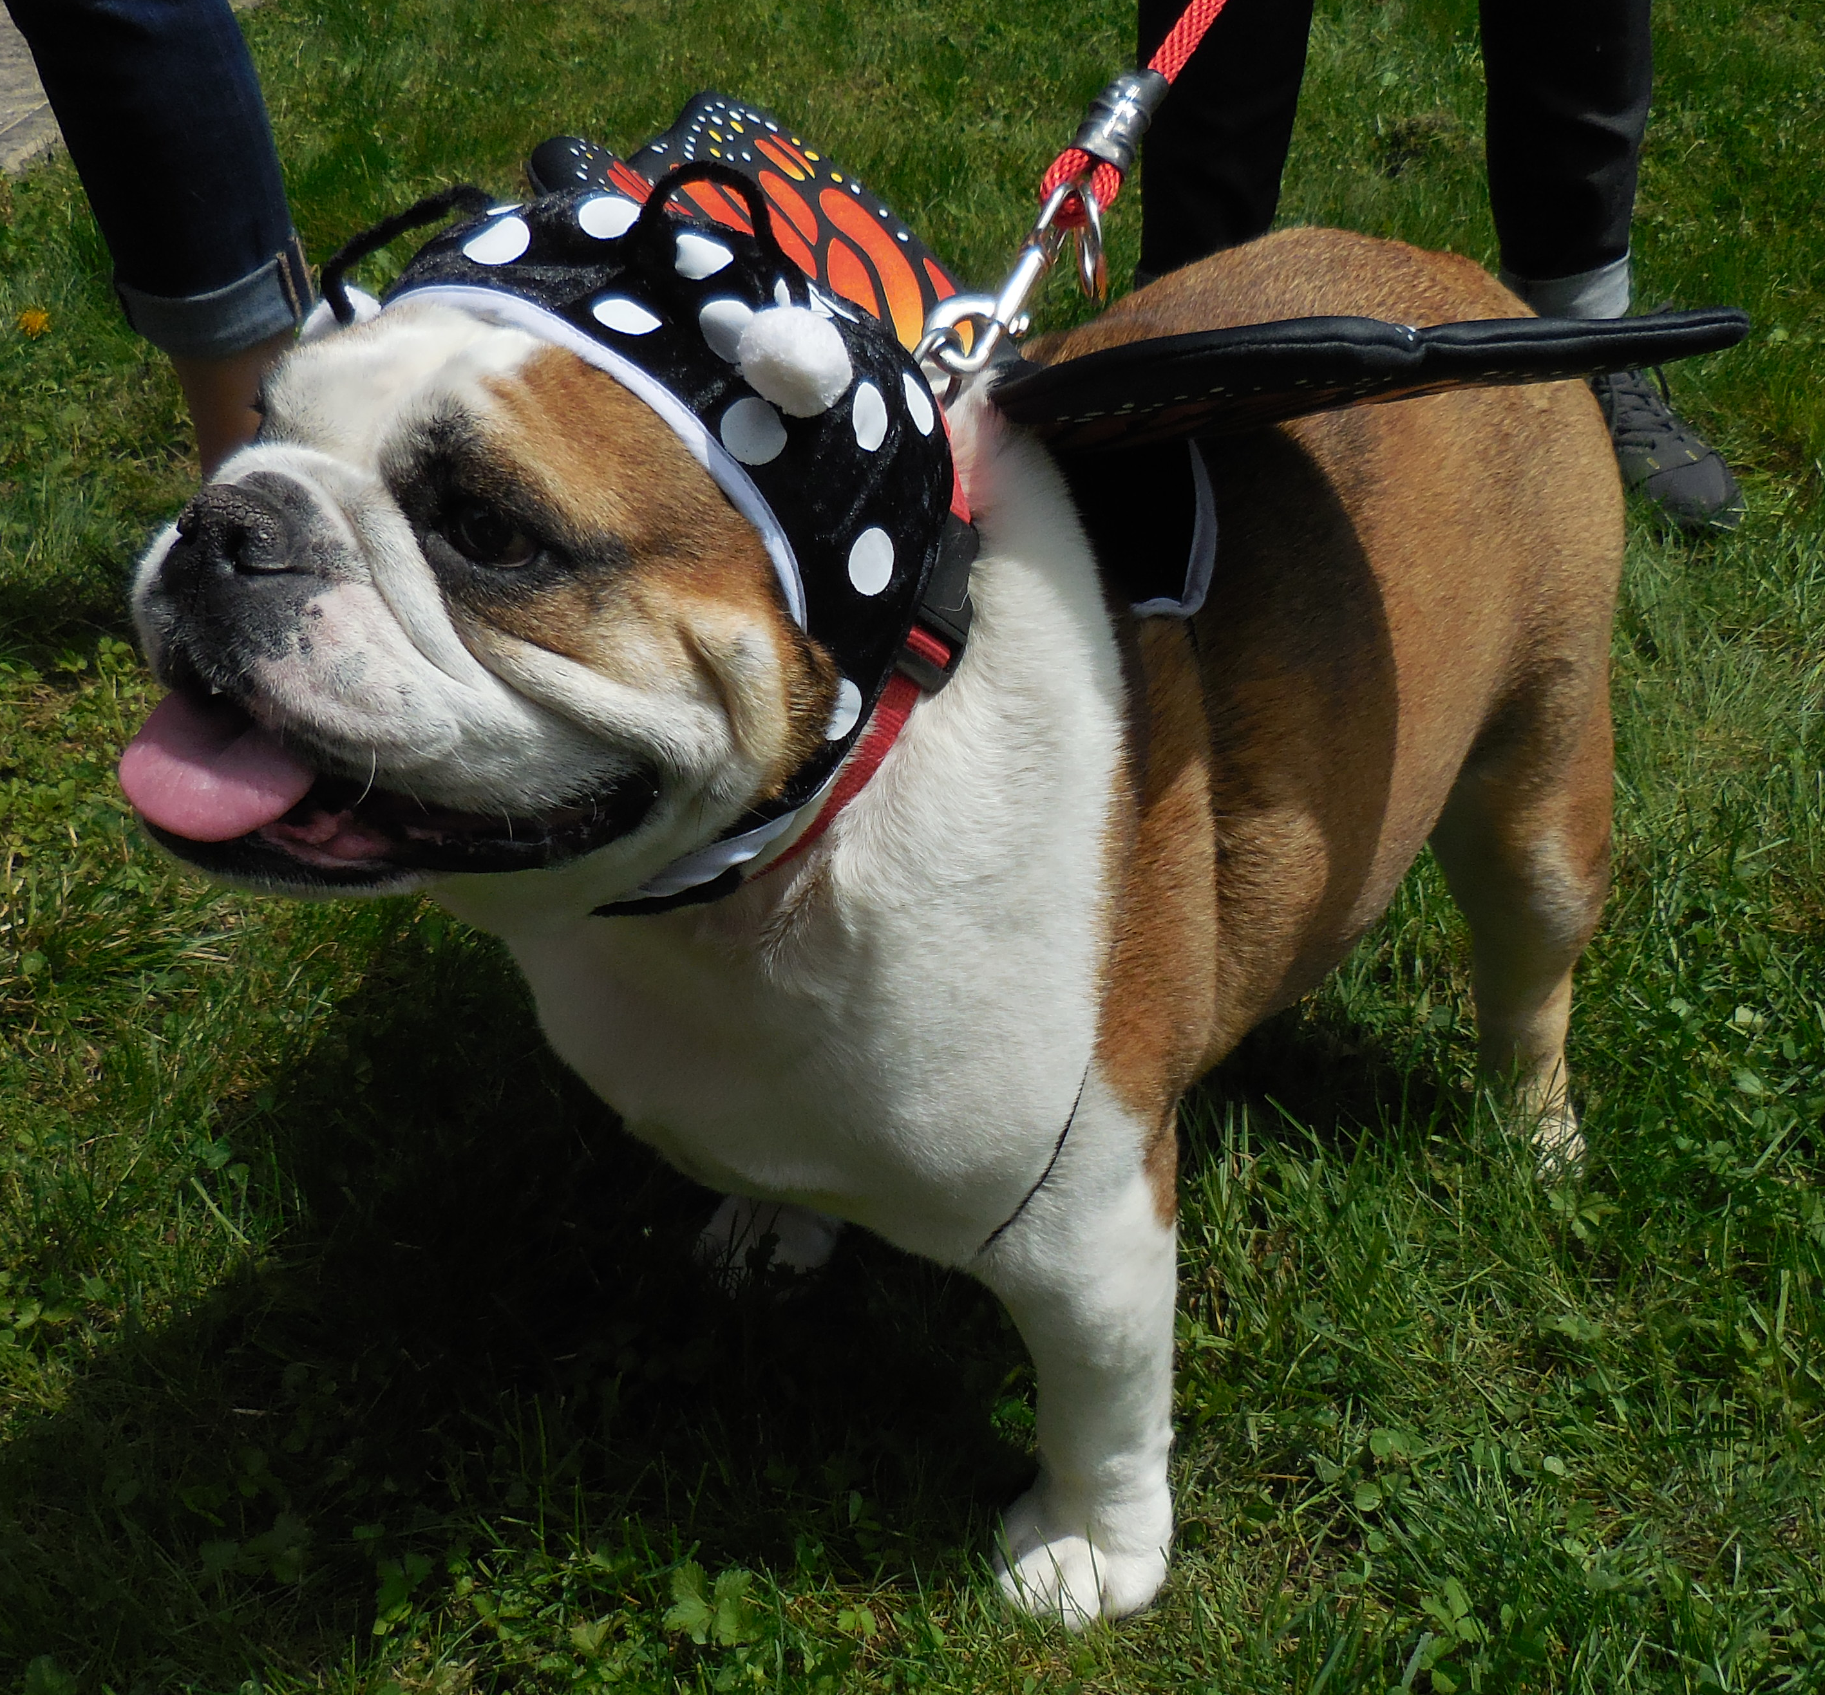






















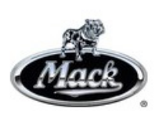
How to Participate:

Fill out Registration Form (on back) and mail to:
America On Wheels Museum
Allentown, PA 18102

Please include a 4x6 glossy photo of your bulldog by April 16th
Accepting the first 30 Bulldogs
FREE ADMISSION: One Owner per Dog

